**Task-3**

# **By Group-6**

Abhinay Samala, Ankush Choudhary, Chhavi, David, Disha Shakyawal, Pasupulati Madhulatha, Parikshit Ramchandra Sahu, Supriya

**Modem Chip IP568x:**

The Modem Chip IP568x is a highly integrated, low-cost, high performance, low-power, full-function modem solution. IP568x implements V.90 to achieve Internet connection rates up to 56 Kbps, supporting existing V.34 data mode, video-ready interface, Class 1 FAX, TAM (Telephone Answer Machine) and Speakerphone functions. IP568x’s I/O pins allow designers to easily control DAA or design modem for special applications. IP568x is a μDSP-based chip designed specifically for modem application, and it performs high MIPS operations such as V.90, V.34 and V.32 modulation. IP568x provides a serial interface for connecting to codec. IP568x uses high quality design to optimize modem configuration for line condition and provide reliable connection with connection rate ranging from 300 kbps up to 56 Kbps. IP568x is the best choice for designing a modem.

**Internal Architecture:**

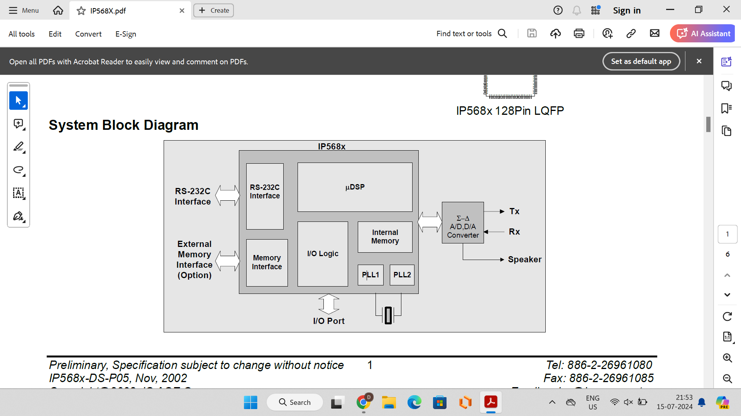

**Modem Application:**

* Standalone Modem
* Embedded Modem Module
* Network Computer
* Set-top Box
* Video Phone

**ICs used inside the Modem-IP568x**  **:**

1. **Digital Signal Processor (DSP):** This is the core IC responsible for executing the complex signal processing algorithms required for modulation, demodulation, error correction, and data compression. It's central to the modem's ability to process digital signals over analog telephone lines efficiently.
2. **Analog Front End (AFE):** This ICs handle the interface between the modem's digital processing core and the analog signals from the telephone line. They typically include components for signal conditioning, analog-to-digital conversion (ADC), digital-to-analog conversion (DAC), filtering, and line impedance matching.
3. **Data Pump ICs:** These ICs manage the conversion between digital data and the analog signals transmitted over the telephone line. They work closely with the DSP to modulate outgoing digital signals into analog signals (transmit) and demodulate incoming analog signals back into digital data (receive).
4. **Codec (Coder-Decoder):** In some modems, especially those with voice capabilities, a codec IC may be included to encode and decode voice signals for transmission over the telephone line. This enables the modem to function as both a data modem and a basic telephony device.
5. **Memory and Control Logic:** ICs for memory (RAM and possibly ROM) store data, firmware, and configuration settings. Control logic ICs manage the overall operation of the modem, coordinating tasks between the DSP, AFE, data pump ICs, and other components.
6. **Interface ICs:** These ICs handle communication between the modem and the host device (e.g., PC motherboard). They may include standard interfaces like PCI, ISA, UART (for serial communication), or USB, depending on the modem's design and intended use.
7. **Power Management ICs:** ICs responsible for managing power distribution and consumption within the modem, ensuring efficient operation and compliance with power management standards.
8. **Protection and Filtering ICs:** These ICs provide protection against electrical surges, filtering to reduce noise on the telephone line, and other measures to ensure reliable operation in various environmental conditions.

**Features and Functionalities of µDSP** :

* **The µDSP features a digital signal processing (DSP) core:**

The central processing unit is specifically built for modem functions. Implements modulation, demodulation, and signal processing methods.

**Programmability:**Firmware-based architecture enables updates and optimization.

Supports a variety of modem standards and setups.

**Integration:**A single-chip system integrates DSP with other critical modem components.

Reduces the number of components and simplifies modem design.

**Power efficiency:**Optimized for low-power operation meets telecoms equipment energy efficiency criteria.

**High-Speed Processing:**Capable of supporting high-speed data transmission and reception.

It supports modulation methods such as Quadrature Amplitude Modulation (QAM) and Phase Shift Keying (PSK).

* **Functions of the microDSP:**

**Modulation and demodulation:**Converts digital data to analog signals for transmission (modulation).Receives and converts analog signals to digital data (demodulation).

**Error correction:**Implements error correction algorithms like Viterbi and Turbo coding.

Ensures accurate data transmission across noisy communication links.

**Signal Processing:**Filters, equalizes, and cancels off echos.Improves signal quality while compensating for line distortions.

**Protocol Handling:**Manages communication protocols used to establish connections (e.g., V.90, V.34).Negotiates data rates and manages protocol-specific functions.

**Data Compression:**Compresses data using algorithms such as V.42bis. Increases data throughput over restricted bandwidth connections.

**Adaptive algorithms:**Adapts to different line conditions and network contexts. Optimizes performance with real-time feedback.

**Interface Control:**Interfaces with analog front-end components and data access arrangements (DAAs). Controls data transfer between the modem and external devices.

**System-level Integration:**Coordinates with integrated circuits to provide analog signal processing and digital control. Ensures smooth operation of the modem system architecture.

**Conclusion:**

In conclusion, the IP568x 56K V.90 Modem Single Chip, utilizing MicroDSP technology, is a highly integrated and versatile solution for modem applications. It supports high-speed data transmission up to 56 Kbps, integrates essential components like DSP, AFE, and codec for voice functions, and ensures efficient power management. Its programmable firmware enables flexibility and adaptation to various modem standards, making it ideal for standalone modems, embedded modules, and diverse consumer electronics. Overall, the IP568x represents a reliable, cost-effective choice for achieving robust internet connectivity and communication capabilities.